**TRAVEL AND TOUR MANAGEMENT SYSTEM**

**Members:**

* **Pranita Maindargikar(39)**
* **Kalash Chandak(11)**
* **Haseeb Sediqi(63)**

**TY.Bsc.Computer Science DIV-A**

**INDEX**

|  |
| --- |
|  |
| **Chapter 1 INTRODUCTION** |
| * **Existing system** |
| * **Problem Definition** |
| **Chapter 2 PROPOSED SYSTEM** |
| * **Proposed System** |
| * **Objective of the system** |
| * **User requirements** |
| * **Operating Environment-Hardwar and Software** |
|  |
| **Chapter 3 ANALYSIS AN DESIGN** |
| * **ERD,UML,Di** |
| * **Class Diagram** |
| * **Use case diagram** |
| * **Sequence Diagram** |
|  |

1. **TRAVEL & TOUR MANAGEMENT SYSTEM**

INTRODUCTION

Everyone has a dream of exploring this beautiful world. Some do it to seek pleasure in form of thrill, adventure, excitement, enjoyment that takes them away from their daily tedious routine while others do it as a hobby or some business purpose. Also promoting tourism is one of the best ways to increase the export of a country and it also increases the **revenue**of a country.

This has boomed the travel and tourism industries across the globe. We find numerous agencies providing all kinds of services to suffice their customers with the best experience in travelling and tourism. Therefore there is a need to check whether the customers are satisfied with the company’s efforts.

EXISTING SYSTEM

The traditional method of planning any tour is to first enquire in companies about their dates, tour costs, packages, offers, etc. For this, customers have to visit companies’ offices, which are available in their areas, collecting brochures or notes to carry home for later use. For booking a tour, documents and payment must be done manually visiting the office again. The tickets of train, bus, flight are also part of tour later collected by customer.

PROBLEM DEFINITION-NEED FOR COMPUTERISATION

Tourism business involves tedious manual tasks like updating tour information, booking, documentation and payment, etc. Therefore main reason of computerization of a system is that it speeds up the tasks saving both time and money. Computer tourism system helps to present data in an effective manner. It also makes inputting information simple for searching and viewing. Moreover, computerizing a system helps to keep business organized. Storing information is vital to a business. In Computerized System data can be stored quickly and indefinitely. Securing business’ valuable data is a huge priority. The use of computerized software can be helpful here. In addition to this, computer software can automate above processes. Last but not the least it also helps to keep data accurate and up-to-date.

PROPOSED SYSTEM

As we see the traditional method involves more efforts on the customer side. Developing a web based software system will reduce just that. Starting from customers visiting the offices itself leaves them with limited options of companies. By putting up the companies’ own websites, can help customer book a tour of company that is geographically far away from him. Later collecting brochures of all the available tours and their details is one the aspects the can be reduced by just visiting a company’s website. The main reason of developing such software is booking. Customers don’t have to visit the offices to submit their documents or paying tour cost. They can do it just by sitting at home. Documents can be emailed to the company and receipt and tickets of the same can be emailed back by the employee easily. In addition to this payment can be done online by net banking or card payment efficiently by connecting companies’ websites to their respective bank’s online transaction software. Further customers can also give their feedbacks about their experience of the tours to companies on their websites. Hence the main objective is to make travelling and tourism easier process for both the company and its customers by developing an application that performs all the necessary operations in order to help reduce manual efforts and flaws.

OBJECTIVES OF SYSTEM

* Develop a web-based application system that automates processes and activities of tour agency and customer details.
* Save company’s time and money.
* Making use of visual data for developing user-friendly web page.
* Ease up customer tasks.

USER REQUIREMENTS

* Easy to use
* System must be secure for both user and admin
* Many user can access the system simultaneously
* payment section should provide the facility of all types of payment methods i.e. online or offline
* System should as well provide the facility of cancellation of the booking
* search engine at the top of the website which helps the user to search for specific tour
* if there is an update in the system it should be displayed on the top of the website
* Contact details option should be there which have Email and phone number

OPERATING ENVIRONMENT-HARDWARE AND SOFTWARE

Hardware

For Travel and Tour Management system to be efficient and full functional:

* at least 512 MB RAM is needed
* at least 1000 MHz processor

Software

The system can operate at any server and it needs the recent versions of internet explorer or any other search engine.

Use Case Diagram

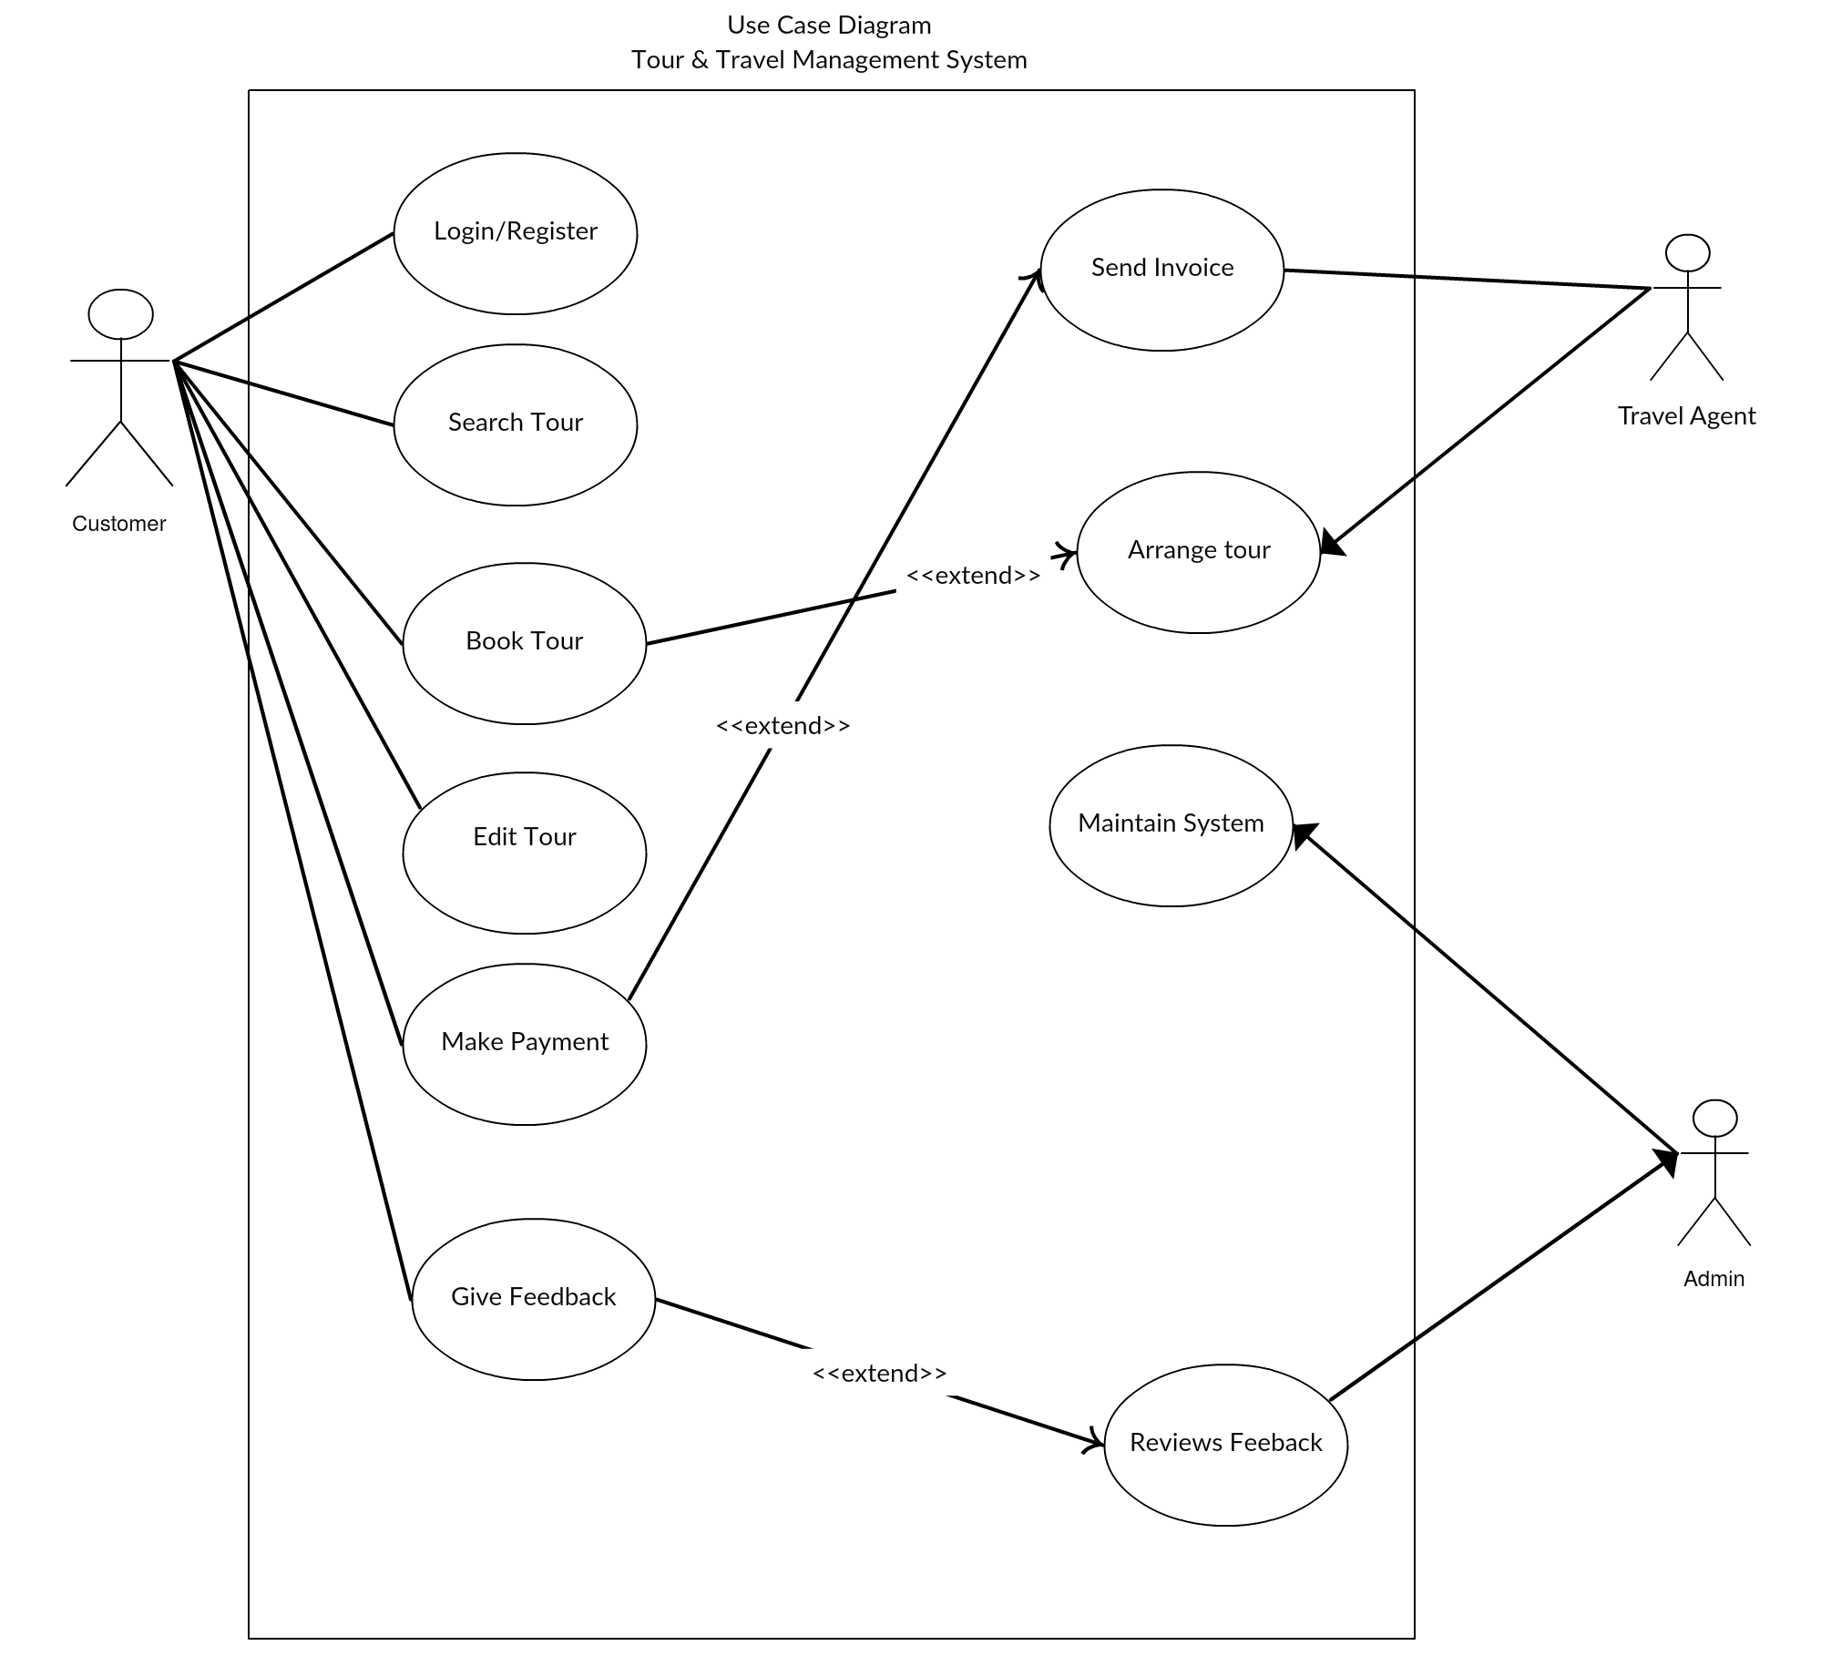

Class Diagram

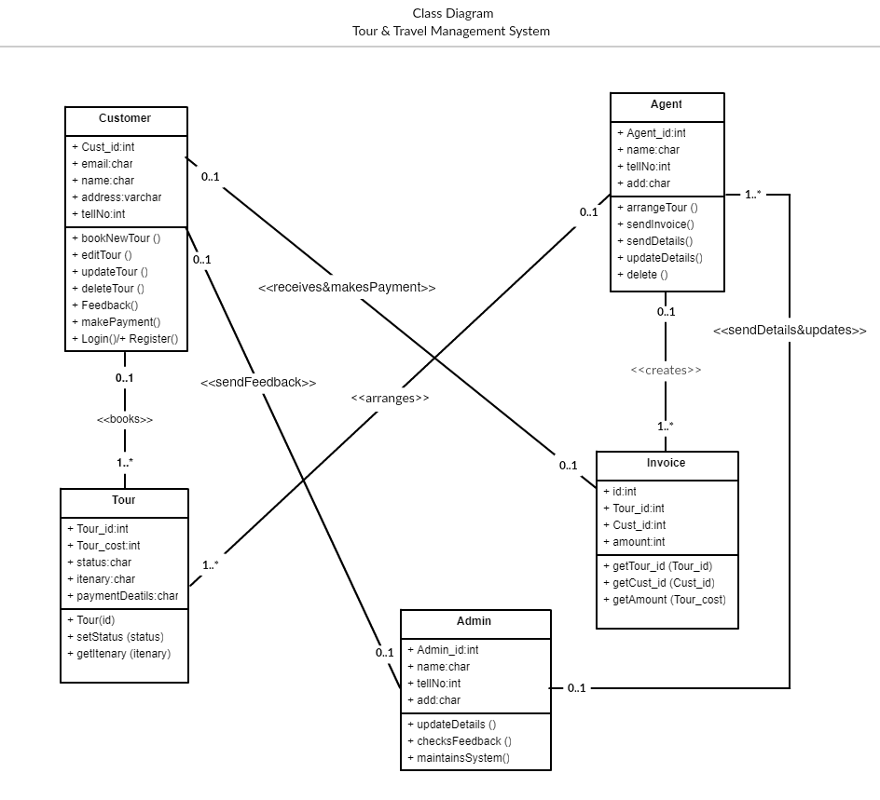

Activity Diagram

# 

LIMITATION OF OUR SYSTEM

Entity Relationship Diagram (ERD)

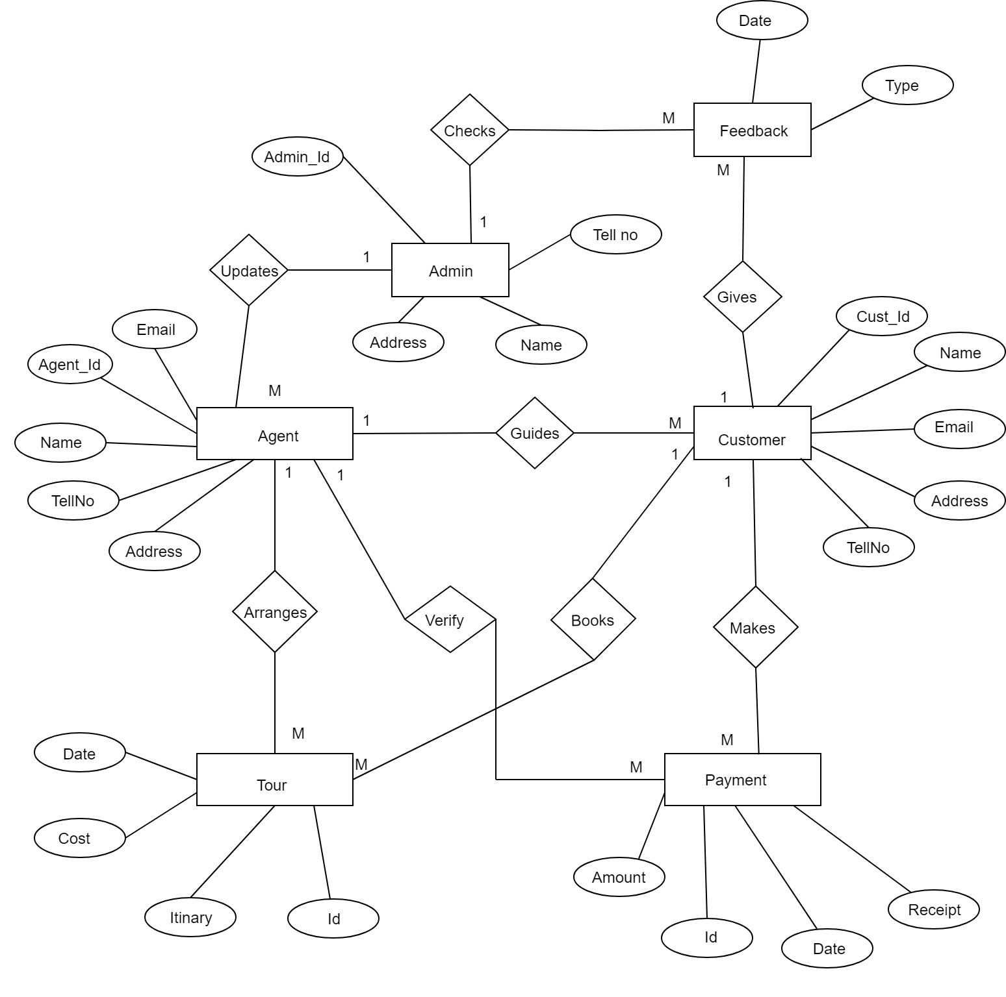

Each and every system has certain drawbacks that lead them towards improper working. In our traditional manual system we are able to booking tickets and packages in our current city only but we want to spread our business worldwide so we choose the online booking method.

* First when the user wants to book the tickets then they have to contact to booking office manually, and that is very time consuming for them.
* The biggest problem in existing system is that the pages of that website are static and not dynamic, so the functionality of the site is not dynamic and the site doesn’t work dynamically.
* And in the existing system there are only some selected cities, so the owner wants to explore his site with adding new cities across the country so in the new site we add more cities as compared to existing system.
* In the existing system the users can only see the packages and the information about the packages but he cannot book the ticket online so we provide the online ticket booking facility in this new website.
* Sometimes due to high data volume there are chances of the server turning down.
* There is huge demand of security in this system.
* It is a step by step procedure where you can’t move further until the previous step is done therefore may be time consuming.

Future Enhancement

Its simplest and maintained and managed easily.

Sequence Diagram

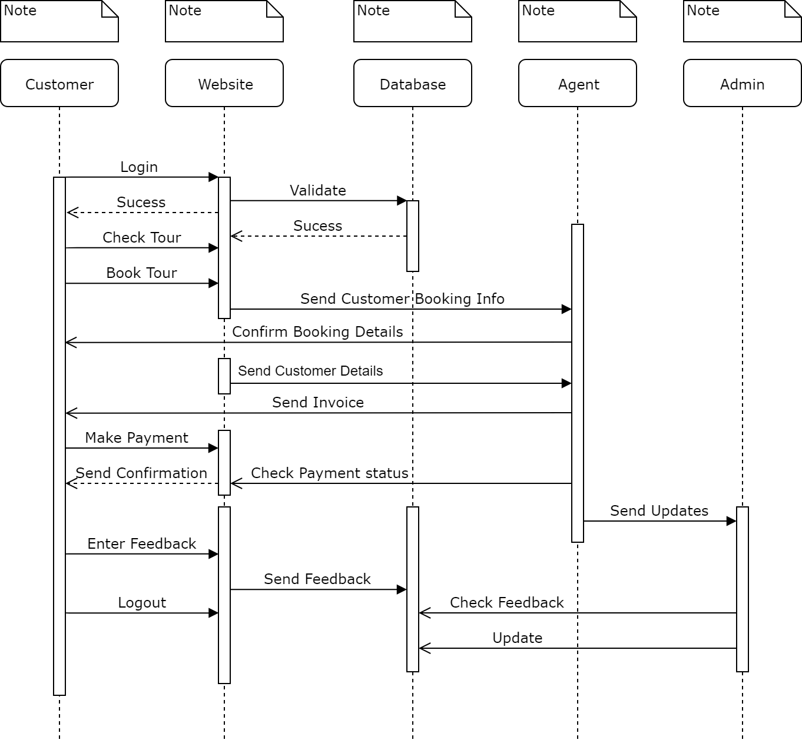

Data Flow Diagram(DFD)

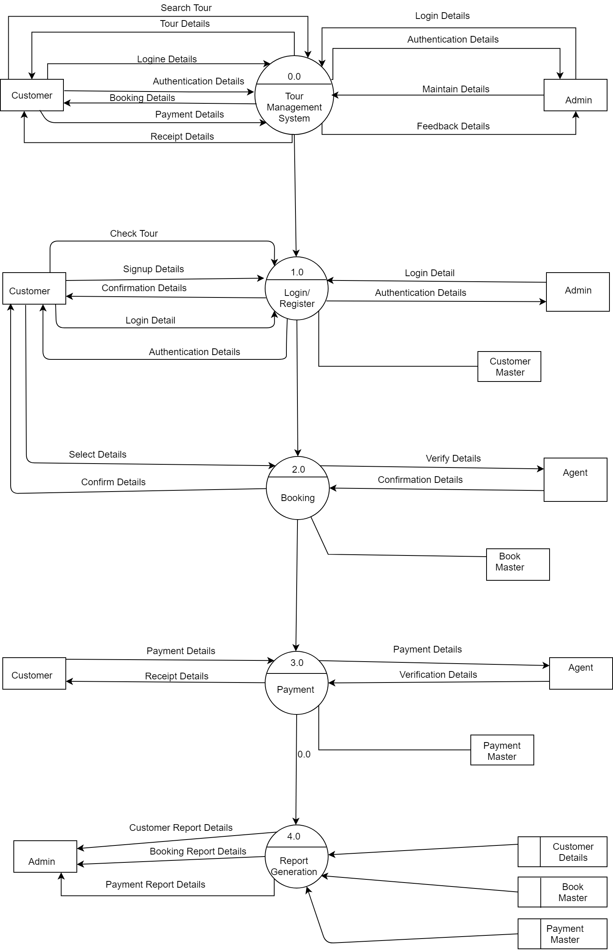

LIMITATION OF OUR SYSTEM

Each and every system has certain drawbacks that lead them towards improper working. In our traditional manual system we are able to booking tickets and packages in our current city only but we want to spread our business worldwide so we choose the online booking method.

* First when the user wants to book the tickets then they have to contact to booking office manually, and that is very time consuming for them.
* The biggest problem in existing system is that the pages of that website are static and not dynamic, so the functionality of the site is not dynamic and the site doesn’t work dynamically.
* And in the existing system there are only some selected cities, so the owner wants to explore his site with adding new cities across the country so in the new site we add more cities as compared to existing system.
* In the existing system the users can only see the packages and the information about the packages but he cannot book the ticket online so we provide the online ticket booking facility in this new website.
* Sometimes due to high data volume there are chances of the server turning down.
* There is huge demand of security in this system.
* It is a step by step procedure where you can’t move further until the previous step is done therefore may be time consuming.

*****END*****